Office Information
R & J Salina Tax News
R & J Salina Tax Service, Inc.  Phone: 785-827-1304 | 12/1/2016  www.randjsalinatax.com | Edition 3, Volume 1  Email: rjtax@salina.kscoxmail.com

Our office and staff have evolved in their training to better assist our clients. When you call, you will be asked what your call pertains to, this will determine how we can best answer your questions and direct your call to the correct person. If you have received IRS or State correspondence, we need to review the letter before we are able to provide assistance. Please bring any correspondence to our office when you receive it.

Privacy & Release of Tax Information

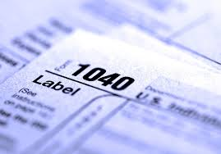In order to protect the privacy and security of our clients, it is our policy to NOT release tax return results over the phone. In addition, we will not email or fax tax returns or anything else that contains sensitive information such as W2s or 1099s. If you are unable to come into the office, we can upload the information you need to the Client Portal. You can download and print the information from there. We can also mail your tax return to you, but only to the address on the tax return.
If you would like us to release your tax return or any other information to a third party, we will need to have a written release of information from you. We are sorry for any inconvenience this might cause, and we appreciate your understanding.
Timothy Graham Jr EA (Tim Jr)
timjrtax@cox.net
Tax Preparer
________________________
Judith Bloyd EA (Judee)
judeetax@cox.net
Tax Preparer
________________________
Tammy Rodgers
tammytax@cox.net
Tax Preparer
________________________
Michelle Johnson (Shell)
shelltax@cox.net
Payroll/Bookkeeping
________________________
Danielle Shelton
rjtax@salina.kscoxmail.com Office Manager

FAFSA

Changes in FAFSA deadlines now allow students and parents to file as early as October 1 using their previous years returns.

Delay in Refunds

In 2017 the IRS will put a hold on refunds on tax returns that are claiming Earned Income Credit (EIC) or the Additional Child Tax Credit (ACTC). Tax returns that are filed before January 31, 2017 will be on hold until February 15, 2017. Tax returns filed after that date will also experience a delay. The IRS will use the extra time to help prevent identity theft and to detect fraud.

R & J Salina Tax Service, Inc. News 2016 2
Documents Your Tax Preparer Needs
To better prepare your tax return, it’s good to know everything your tax preparer may need. This includes identification, income documents, and expense documents.
The IRS and state tax agencies are increasingly cracking down on people who claim the same dependent more than once, such as estranged parents both claiming the same child.
Tax preparers are asking that you provide Social Security cards for yourself and your dependents. This helps eliminate electronic filing errors by making sure the name and Social Security numbers match with the IRS records.
You also need to bring documents that show all your income for the year. These documents are W-2’s from your employers, 1099-MISC forms for self-employment income, 1099-INT (interest) and 1099-DIV (dividend) forms, 1099-B forms showing brokerage trades in stocks and bonds, K-1 forms for income from a partnership, small business, or trust, 1099-SSA form showing Social Security benefits received.
Be sure to bring written documents for additional income that was not reported on a W-2 or 1099 form, such as other self-employment income, rental income, or alimony. You can provide this in a spreadsheet, bank statement, or written evidence. Bring canceled checks, receipts, or spreadsheets for any tax-related expenses. This includes contributions to your traditional or SEP-IRA, moving expenses, college expenses, medical and dental expenses, real estate taxes, gifts to charities and churches, and daycare or child care costs. Some of these expenses are reported to you. Mortgage interest is on a Form 1098-M and student loan interest is on a Form 1098-E. Please bring in a detailed list of estimated taxes you have paid throughout the year as well. Also, for prescriptions you can ask your pharmacist to print out a summary instead of bringing in all your prescription receipts. Please make sure you have all your tax information before coming in for your appointment, or dropping it off.

Identity Theft PIN
• • •
If you have been a victim of IRS identity theft, the IRS will send you a PIN. You will need this PIN in order to e-file your federal tax return. It is a one-time use number (you should receive a new one every year), and you should be receiving it in the mail in early January. Do NOT throw this number away. Last year the IRS mislabeled the form with the wrong year, and those who threw it away had to go through the hassle of replacing it.

Please Remember

When coming in for your appointment or to drop off your tax information, we will need a copy of the taxpayer’s and spouse’s driver’s license. Also, we will need copies of social security cards for taxpayer, spouse and all dependents. If you have power of attorney or executorship, we will need copies of this too. Please come in 15 minutes before your scheduled appointment. This will give us time to check you in. Thank you in advance for your cooperation.
FILING DATE CHANGES
- FORM 1065- For Partnerships and LLC’s taxed on Form 1065 the filing deadline is March 15, 2017
- FORM 1120 – For C-Corporations the filing deadline is April 15, 2017
- FORM 1120S- For S-Corporations the filing deadline is March 15, 2017

Important Information!

Documentation requirements have been increased for all refundable tax credits, which includes the EITC (Earned Income Tax Credit), Child Tax Credit (for children under the age of 17), and the AOTC (American Opportunity Tac Credit for the first 4 years of college undergraduate studies). Before we can prepare your return, you must provide the proper documentation in order to claim these credits. Examples of documentation for each credit are listed below.
EITC | CHILD TAX CREDIT | AOTC
Social security cards  Birth Certificates  Marriage Certificate  Divorce Certificate  School Statement  Doctor’s Statement  Lease showing the residents of the household  Court records  Placement agency paperwork | Social security cards  Birth Certificates  Marriage Certificate  Divorce Certificate  School Statement  Doctor’s Statement  Lease showing the residents of the household  Court records  Placement agency paperwork  Form 8832* | Receipts from school to substantiate Form 1098-T  Loan disbursement schedules  Receipts for books  Receipts for course materials  Form 1098-T  Billing and payment summary from the university
*Unique to child tax credit. Form 8332 does not impact who can claim the child for EITC, but it does for the child tax credit.
In addition, if you have a Small Business reported on Schedule C, you will be asked to fill out a questionnaire and supply documentation to substantiate your business, such as bank statements or advertising examples.
Upon request, we can provide more detailed examples provided by the Internal Revenue Service for each of the credits. If you have any questions, please call the office and we will be happy to assist you.

R & J Salina Tax Service, Inc. News 2016 3

  - For Your Information…
R & J Salina Tax Service, Inc. 2016 4
1099’s & W2’s
Any client that needs our service to prepare 1099’s for them will need to provide W-9’s in order for us to prepare the 1099’s. This helps to eliminate any errors. The W-9’s provides us the addresses, social security numbers, and EIN’s that we need. The due date for 1099’s and W2s to be completed is January 31, 2017, or significant penalties will be assessed.
Copy Fees
We will be happy to get you copies of your tax returns. The current year and most recent previous year will be free of charge one time. For all other years and for additional copies there will be a $25 service fee per year.
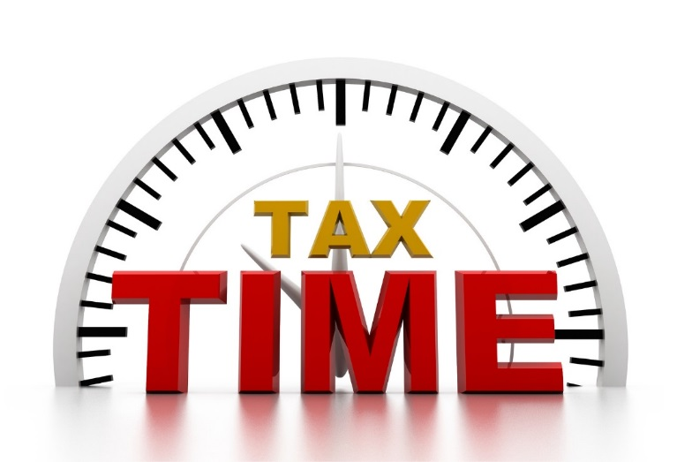

Affordable Care Act
For tax year 2016, you will need to provide us with proof you had health insurance in 2016. This can be either a Form 1095A, 1095B, 1095C, or a copy of your health insurance card and a signed affidavit.
If you can not or do not provide us with proof of health insurance coverage, it will be assumed that you did not have coverage and the IRS will assess penalties on your tax return.

Travel Per Diem Rates
The M&IE rates for the transportation industry increased from $59 to $63 for travel in the continental U.S. and from $65 to $68 outside the continental U.S.
Night drop, Fax & Email
When leaving information in our night drop slot, faxing or emailing, please make sure it has a name and phone number for the person or business the information pertains to. This will help us insure it gets to the correct place.

Mileage Rates
The Business Mileage rate for 2016 is .54 per mile. The mileage rate for Medical and Moving is .19. The rate for charitable mileage is .14.

Daycare Rates
The Tier 1 Daycare breakfast rate is $1.32. The Lunch/Supper rate is $2.48. The Snack rate is .74.
Email Address
If you provide us an email address, we will be able to email you reminders about your appointment time and notify you when your tax return is done.
New Babies
If you had a new baby in 2016, we will need to copy the baby’s social security card.

WARNING!!!
If we do not have a Form 8879 signed by the taxpayer your tax return will NOT be filed. You will get this form to sign when you pick up your tax return.

BEWARE OF SCAMS INVOLVING THE IRS!!!

The IRS is warning taxpayers to stay vigilant against an increase in IRS impersonation scams in the form of automated calls and new tactics by scammers demanding payment on iTunes gift cards and other gift cards.
There has been an increase in “robocalls” where the scammers leave an urgent callback message for taxpayers to call back and settle their “tax bill”. These calls are the “last warning” before legal action is taken. If the victim calls the number back, they are threatened with arrest, deportation, or revocation of driver’s license if they do not pay. The latest scams are demanding that payment to the IRS be made by putting money on an iTunes or other gift cards.
These bogus calls can take many forms and scammers are constantly changing their methods. Knowing the signs that it is a scam is the best way to avoid becoming a victim.
THE IRS WILL NEVER:
- Call to demand immediate payment over the phone, nor will the IRS call about taxes owed without having first mailed a bill.
- Threaten you with arrest for not paying
- Demand payment for taxes without giving you the opportunity to question or appeal the amount they say you owe.
- Require you to use a specific payment method for your taxes, such as a prepaid debit card, gift card or wire transfer.
- Ask for credit or debit card numbers over the phone

If you get a phone call or even an email from someone claiming to be from the IRS demanding payment, here is what you should do:
- DO NOT give out any information, HANG UP immediately!
- Contact the TIGTA (Treasury Inspector General for Tax Administration), using their webpage or call 1-800-366-4484
- Call R & J Salina Tax Service, and we will assist you in determining if it is a scam!

R & J Salina Tax Service, Inc. News 2016 5

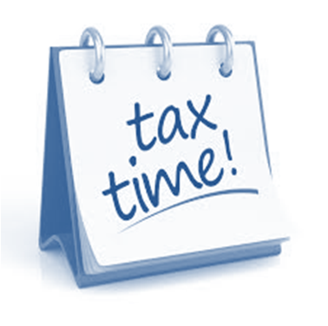
R & J Salina Tax Service, Inc.
318 W. Cloud St
Salina, Ks 67401
[Type the recipient name]
[Type the recipient company name]
[Type the recipient address]

Make your appointment now!
To better assist you with filing your 2016 tax return, call and schedule an appointment. This way you can get in when it is convenient for you. Spots will fill up fast!

